A student measured the resistance R of a wire of length 30 cm at different values of temperature θ. The following data were recorded.
- Draw a labelled diagram of how the apparatus was arranged in this experiment.
- How did the student make the temperature of the wire 0 °C? (15)
θ (°C) 0 20 40 60 80 100
R (Ω) 5.35 5.60 5.85 6.04 6.28 6.51
- Draw a suitable graph to show the relationship between R and θ.
- Use your graph to determine the temperature when the resistance is 6 Ω. (12) The student measured the diameter of the wire to be 2.4 mm.
- How did the student measure the diameter of the wire?
- Calculate the resistivity of the metal at a temperature of 20 °C. (13)
In an experiment to verify Joule’s law a constant current I was passed through a heating coil immersed in water.
The current was allowed to flow for four minutes and the rise in temperature Δθ was determined.
This procedure was repeated for a number of different currents.
The mass of the water was kept constant at 105 g.
The following data were recorded.
I (A) 1.0 1.5 2.0 2.5 3.0 3.5
Δθ (°C) 2.0 4.6 8.2 12.6 18.3 25.0
- Draw a labelled diagram of how the apparatus was arranged in this experiment.
- Why was the current allowed to flow for a constant period of time? (15)
- Draw a suitable graph to verify Joule’s law.
- Use your graph to calculate the average resistance of the heating coil. (25) (specific heat capacity of water = 4180 J kg‐1 K‐1)
In an experiment to determine the resistivity of nichrome, the resistance R of a length l of wire of uniform diameter was recorded. This was repeated for a number of different lengths of the wire. The diameter of the wire was also measured. The following data were recorded.
l (cm) 30 40 50 60 70 80
R (Ω) 0.11 0.14 0.17 0.21 0.24 0.28
Diameter of wire = 2.05 mm
- Name the pieces of apparatus that were used to measure (a) the diameter, (b) the length and (c) the resistance of the wire.
- How did the student ensure that the diameter of the wire was uniform? (12)
- Use the data to draw a graph of R against l.
- Calculate the slope of your graph.
- Hence calculate the resistivity of the metal. (21)
- How would the resistance of a fixed length of wire change if its diameter was doubled? (7)

In an experiment to investigate the variation of current I with potential difference V for a semiconductor diode the following data were recorded.
V (mV) 0 50 100 150 200 250 300
I (mA) 0 0 0 2 5 40 110
Draw a circuit diagram for this experiment. (15)
Use the data to draw a graph of current against potential difference.
Use your graph to determine the junction voltage.
What happened in the diode when the junction voltage was exceeded
Is Ohm’s law obeyed for the diode? Justify your answer.
The diode is now reversed and data is recorded. State two other changes that are made to the circuit before recording data for a diode in reverse bias. (25)
In an experiment to measure the variation of the resistance R of a metallic conductor with its temperature θ, a student recorded the following data.
θ (°C) 15 20 30 40 50 60 80 100
R (Ω) 6.0 6.2 6.5 6.8 7.2 7.5 8.2 8.8
Using the recorded data, plot a graph to show the variation of the resistance of the metallic conductor with its temperature. Use your graph to estimate
- the rate of change of resistance with respect to temperature for the metallic conductor
- the resistance of the metallic conductor when it is immersed in melting ice. (20)
The student then completed an experiment to establish the relationship between current and voltage for the thin metallic filament of a bulb.
Data were recorded and the following graph plotted.
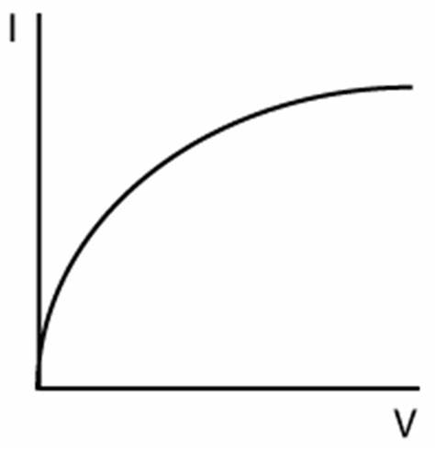

Describe, with the aid of a circuit diagram, how the student carried out this second experiment.
Use the findings of the first experiment to explain the shape of the graph in the second experiment. (20

